**JIRA Software [WebGentle]**

**Agenda**

1)What is JIRA?

2) Why should we use Jira?

3)What are the Jira Products?

4)Which agile methodology used in Jira?

======================================================================

1. **Jira is :**

* **Project management,**
* **Test management**
* **Issue[bug] tracking,**
* **and bug tracking tool- for agile software and business teams. It is a part of software testing.**
* It is completely a REST API based tools.
* All the functionality which we can want to perform in JIRA like
* I want to -report a bug, create a new task, delete a bug and update the details of the bug. So everything we can do using Jira whatever you need.

========================================================

1. **Why should we use Jira?**

* Jira has everything that you need to manage projects and teams.
* It has able to track project progress from time to time.
* Jira use cases include project management,future implementation, bug tracking etc.
* Bug flow can be easily customized as per our requirement
* It is fully customizable to your needs.
* you can customize your workflow,
* you can add your custom issue types,
* you can add your fields,
* you can design your **issue operations screen** as per your team requirements and
* We can get the report out of jira like –BurnDown chart, BurnUP chart,Control chart, sprint report*, Average age report, Pie chart report, Time Tracking Report
* **Countless add-ons to further enhance the functijhonality.** If I say About the marketplace of the Jira where you can find various Apps that are used to enhance the functionality of Jira. So you can use any App according to your requirements.
* Jira has lots of features which make our life easier.

=====================================================================

**Question – Explain JIRA workflow/**

Workflow means a series of steps and issue or bug goes through during its life cycle from creating to closing of an issue. The workflow includes the creation of an issue that means creation are open an issue and then series of actions for formal to fix the issue and the last things includes the closing or completion of the issue after verification.

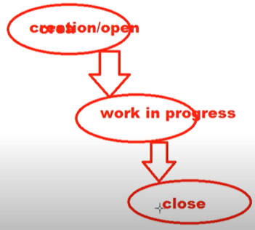

Question – What type of reports generated by JIRA?

There are multiple reports available in JIRA which are used to show the project statistics through the project lifecycle.

Using JIRA we can get Agile report –

BurnDown chart[how much work is remaining to be done],

Burnup Chart[How much work has been completed],

Sprint report[Understand the work completed or pushed back to the backlog in each sprint],

Velocity chart[Track the amount of work completed from sprint to sprint],

Control chart[it shows the cycle time for product, sprint or version in the current process to determine future performance].

And we can get Issue Analysis Report like -Average Age report[It shows the average age of unresolved issues for a project or filter],

pie chart report[It shows a pie chart of issues for a project or filter ground by a specified field. This helps you to see the breakdown of a set of issues at a glance], and

Forcast & Management Report like

Time traking report[Shows the original and current **time estimates for issues** in the current project. This can help you determine whether work is on track for those issues.],

User worked load report [Shows the time estimates for all unresolved issues assigned to a user across projects to understand the user's workload better]and other reports we can get easily .

=====================================

**Explain step by step procedure of how an issue created in JIRA?**

Whenever an issue or defect is encountered while testing.It needs to be reported. so that the developers can work on it and take the necessary action to fix it.

To create an issue /bug step by step in JIRA first you need to

* login to your JIRA account by using valid credentials and
* get direct to the dashboard.
* In the jira dashboard then you need to click on create button .
* Then it will navigate to a window for creating an issue. Then you will find bug, tasks,story and Epic. so you can right here some issue like story .
* and then you need to enter all necessary details as required to create an issue.

After that click on finally create button to create an issue .so in this way you can create any issue in JIRA..

**=================================================**

**Question-** **Question- Explain Three color indicators and their significance?**

Any particular issue in JIRA three colors like **blue**, **green** and **orange** is used to denote the amount of time spent on any particular issue.

This information is displayed under time tracking section.So in the dashboard in the JIRA software dashboard you can see here time dragging.

So **blue color** means this color is to denote **original estimate** that is -that time estimate to be invested in resolving the issue that means it is estimated time.

The orange color determines the time left for resolving the issue. This field has been labeled as remaining.

If it is green color, this color defines the actual time that has been used or days spent in resolving the issue so far.This field has been labeled as logged.

=====================================================================

**Question -How is an issue linked to zero ?**

Question-Explain how particular project details are listed in JIRA?

**================================================================**

**Question – How to setup Account in jira?**

* To create project
* To create user
* Assign the user to the project
* Open REST API document

=============================================================================

**What are the Jira products?**

Jira is a family of products which built to help all types of the teams to track their work. There are 4 products built on Jira Platform:

1. Jira Core, 2) Jira software, 3) Jira Service Desk, and 4) Jira Ops.

* What is Jira Core?

It's allow you to track issues using customizable workflow which basically determines ---

how an issue can flow from start to completion and what are the others steps along with,

This basic functionality that would you get with jira core which is the base bare minimum jira tool that you can use for simple business-related projects and task management.

===========================

Jira software--With Jira Software which we will be use in this complete course.

you have extra agile functionality where you can track software projects which agile methodologies. In other words Jira Software includes both Jira Core plus Agile methodologies.

what is Jira Service Desk?

It is the service desk which is used for support projects. Using jira service desk you can give the better experience to your customers, they can easily ask for help and your agent can response them in a faster way, in a better way.

Jira Ops- it is an incident management tool. it is used to centralized alerts and notify the right people at the right time.

================================================================

Which agile methodology used in Jira?

* Jira software is an agile project management tool that supports any agile methodology, be it scrum, kanban, or your own unique flavor.
* You can use Scrum, Kanban, mixed methodologies or agile scale .
* Jira software fit your frameworks scrum, kanban or your unique other one. =================================================================

Jira is a project management tool, because using JIRA we can manage infact

* Test cases
* Defect
* project
* Sprint

We can get the report out of jira like –

A. Agile-under the agile environment --

1. Burndown Chart
2. Burnup chart
3. Sprint Report
4. Velocity chart
5. Version report
6. Cumulative flow diagram
7. Epic Report
8. Control chart
9. Epic Burndown
10. Release Burndown

B. Issue Analysis

1) Average Age Report

2) Pie Chart Report

3) Created vs Resolved Issues Report

4) Single level Group by Report etc.

C.Forecast & Management Report

1) Time Tracking Report

2) User workload Report

3) Version workload Report

D. Other

1) Workload Pie Chart Report

So we can do lot of things using the jira compare to other defect management tools.

The story point is nothing but ,let’s say there is one feature which you want to design.

Example of Payment page –like the story is going to be, I want write the code for net banking that is the story.

Epic – the epic is the bigger story. The story in which we can split multiple

Story ,so that the story portions of the story

Like Payment page is the Epic. If In the payment page there will be

* a net banking
* a paypal
* a checking
* credit card

So story can be the individual story. Epic is the multiple/ bigger part of story.

Story -into Backlog

After creating Story > go to Backlog> click on Active Sprint on this page > then we can create the sprint.

So Go to project option at top> click on this> click on project where you want to work>

We need to start the work that how the sprint work. In the one story it can be 10/20 story.

We get the following report in the JIRA.

A--Agile-under the agile environment --

[Burndown Chart](https://team-1609637333100.atlassian.net/secure/RapidBoard.jspa?projectKey=BR&rapidView=1&view=reporting&chart=burndownChart)

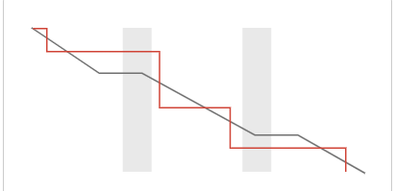 Track the total work remaining and project the likelihood of achieving the sprint goal. This helps your team manage its progress and respond accordingly.

[Burnup Chart](https://team-1609637333100.atlassian.net/secure/RapidBoard.jspa?projectKey=BR&rapidView=1&view=reporting&chart=burnupChart)

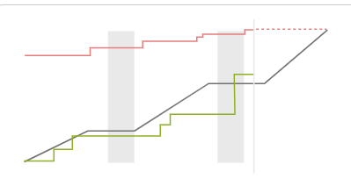Track the total scope independently from the total work done. This

helps your team manage its progress and better understand the effect of scope change.

[Sprint Report](https://team-1609637333100.atlassian.net/secure/RapidBoard.jspa?projectKey=BR&rapidView=1&view=reporting&chart=sprintRetrospective)

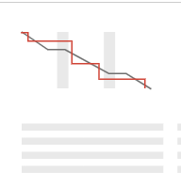Understand the work completed or pushed back to the backlog in each sprint. This helps you determine if your team is overcommitting or if there is excessive scope creep.

[Velocity Chart](https://team-1609637333100.atlassian.net/secure/RapidBoard.jspa?projectKey=BR&rapidView=1&view=reporting&chart=velocityChart)

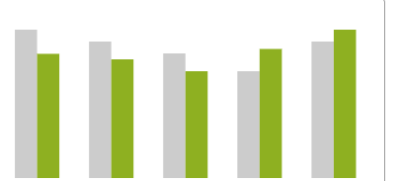Track the amount of work completed from sprint to sprint. This helps you determine your team's velocity and estimate the work your team can realistically achieve in future sprints.

[Cumulative Flow Diagram](https://team-1609637333100.atlassian.net/secure/RapidBoard.jspa?projectKey=BR&rapidView=1&view=reporting&chart=cumulativeFlowDiagram)

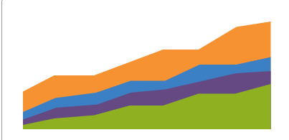

Shows the statuses of issues over time. This helps you identify potential bottlenecks that need to be investigated.

[Version Report](https://team-1609637333100.atlassian.net/secure/RapidBoard.jspa?projectKey=BR&rapidView=1&view=reporting&chart=versionReport)

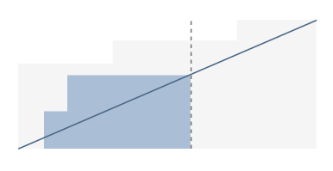

Track the projected release date for a version. This helps you monitor whether the version will release on time, so you can take action if work is falling behind.

[Epic Report](https://team-1609637333100.atlassian.net/secure/RapidBoard.jspa?projectKey=BR&rapidView=1&view=reporting&chart=epicReport)



Understand the progress towards completing an epic over time. This helps you manage your team's progress by tracking the remaining incomplete/unestimated work.

[Control Chart](https://team-1609637333100.atlassian.net/secure/RapidBoard.jspa?projectKey=BR&rapidView=1&view=reporting&chart=controlChart)

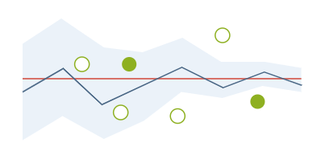Shows the cycle time for your product, version or sprint. This helps you identify whether data from the current process can be used to determine future performance.

[Epic Burndown](https://team-1609637333100.atlassian.net/secure/RapidBoard.jspa?projectKey=BR&rapidView=1&view=reporting&chart=epicBurndown)

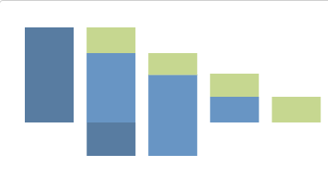

Track the projected number of sprints required to complete the epic (optimized for Scrum). This helps you monitor whether the epic will release on time, so you can take action if work is falling behind.

[Release Burndown](https://team-1609637333100.atlassian.net/secure/RapidBoard.jspa?projectKey=BR&rapidView=1&view=reporting&chart=releaseBurndown)

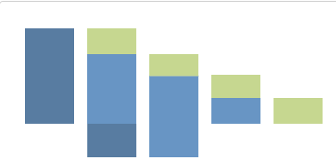

Track the projected release date for a version (optimized for Scrum). This helps you monitor whether the version will release on time, so you can take action if work is falling behind.

B.Issue analysis

[Average Age Report](https://team-1609637333100.atlassian.net/secure/ConfigureReport!default.jspa?selectedProjectId=10000&projectOrFilterId=project-10000&projectOrFilterName=Birth%20Registry&reportKey=com.atlassian.jira.plugin.system.reports:averageage-report)

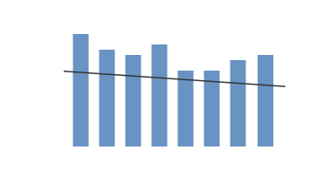

Shows the average age of unresolved issues for a project or filter. This helps you see whether your backlog is being kept up to date.

[Created vs. Resolved Issues Report](https://team-1609637333100.atlassian.net/secure/ConfigureReport!default.jspa?selectedProjectId=10000&projectOrFilterId=project-10000&projectOrFilterName=Birth%20Registry&reportKey=com.atlassian.jira.plugin.system.reports:createdvsresolved-report)

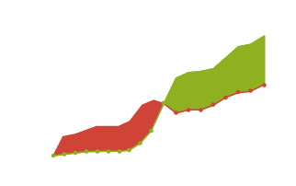

Maps created issues versus resolved issues over a period of time. This can help you understand whether your overall backlog is growing or shrinking.

[Pie Chart Report](https://team-1609637333100.atlassian.net/secure/ConfigureReport!default.jspa?selectedProjectId=10000&projectOrFilterId=project-10000&projectOrFilterName=Birth%20Registry&reportKey=com.atlassian.jira.plugin.system.reports:pie-report)

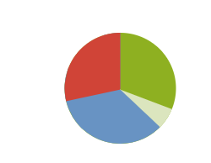

Shows a pie chart of issues for a project/filter grouped by a specified field. This helps you see the breakdown of a set of issues, at a glance.

[Recently Created Issues Report](https://team-1609637333100.atlassian.net/secure/ConfigureReport!default.jspa?selectedProjectId=10000&projectOrFilterId=project-10000&projectOrFilterName=Birth%20Registry&reportKey=com.atlassian.jira.plugin.system.reports:recentlycreated-report)

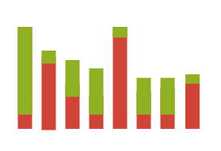

Shows the number of issues created over a period of time for a project/filter, and how many were resolved. This helps you understand if your team is keeping up with incoming work.

[Resolution Time Report](https://team-1609637333100.atlassian.net/secure/ConfigureReport!default.jspa?selectedProjectId=10000&projectOrFilterId=project-10000&projectOrFilterName=Birth%20Registry&reportKey=com.atlassian.jira.plugin.system.reports:resolutiontime-report)



Shows the length of time taken to resolve a set of issues for a project/filter. This helps you identify trends and incidents that you can investigate further

[Single Level Group By Report](https://team-1609637333100.atlassian.net/secure/ConfigureReport!default.jspa?selectedProjectId=10000&projectOrFilterId=project-10000&projectOrFilterName=Birth%20Registry&reportKey=com.atlassian.jira.plugin.system.reports:singlelevelgroupby)



Shows issues grouped by a particular field for a filter. This helps you group search results by a field and see the overall status of each group.

[Time Since Issues Report](https://team-1609637333100.atlassian.net/secure/ConfigureReport!default.jspa?selectedProjectId=10000&projectOrFilterId=project-10000&projectOrFilterName=Birth%20Registry&reportKey=com.atlassian.jira.plugin.system.reports:timesince-report)

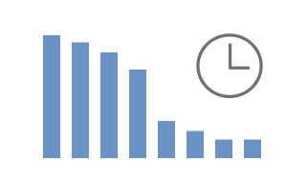

For a date field and project/filter, maps the issues against the date that the field was set. This can help you track how many issues were created, updated, etc, over a period of time.

## Forecast & management

[Time Tracking Report](https://team-1609637333100.atlassian.net/secure/ConfigureReport!default.jspa?selectedProjectId=10000&projectOrFilterId=project-10000&projectOrFilterName=Birth%20Registry&reportKey=com.atlassian.jira.plugin.system.reports:time-tracking)



Shows the original and current time estimates for issues in the current project. This can help you determine whether work is on track for those issues.

[User Workload Report](https://team-1609637333100.atlassian.net/secure/ConfigureReport!default.jspa?selectedProjectId=10000&projectOrFilterId=project-10000&projectOrFilterName=Birth%20Registry&reportKey=com.atlassian.jira.plugin.system.reports:developer-workload)



Shows the time estimates for all unresolved issues assigned to a user across projects. This helps you understand the user's workload better.

[Version Workload Report](https://team-1609637333100.atlassian.net/secure/ConfigureReport!default.jspa?selectedProjectId=10000&projectOrFilterId=project-10000&projectOrFilterName=Birth%20Registry&reportKey=com.atlassian.jira.plugins.jira-software-plugin:version-workload-report)



Shows the time estimates for all unresolved issues assigned to a version, broken down by user and issues. This helps you understand the remaining work for the version.

**Other-**

[Workload Pie Chart Report](https://team-1609637333100.atlassian.net/secure/ConfigureReport!default.jspa?selectedProjectId=10000&projectOrFilterId=project-10000&projectOrFilterName=Birth%20Registry&reportKey=com.atlassian.jira.ext.charting:workloadpie-report)



A report showing the issues for a project or filter as a pie chart.

**==================================================================**

**Bhanu Ist Vedio**

* Create a project , create a story. Create a sprint-First vedio

To create project –go to project >click Create a project-->Scrum software development> give the project name>submit

To create a story point -first you have to create story point-

Click on create> Select the project >Give issue type> give the summery{like desing netbanking integration}> create one more story. Then click on Active sprint>

To do that > first select the project to click on project options> click on create a boad> So create a scrum boad> can click on board from the existing project>

So you click on backlog then you can see the here you have created on sprint option.> click on create on sprint. > then you will seen how many sprint you have > then to design the sprint drag and drop the story > then add on more story 🡪click on create issue then go to right side to click [three dot option] > get a box > give the summery and other on this create issue box. > click on create> then two story got created.

Now need to start the jira.> click on start sprint > then you give the duration of sprint.> sprint got started,

Once the sprint is started > when you click on Active sprint , you will come to sprint dashboard.

===========================

**Bhabu 2nd vedio**

**Like we have this two stories to be done**

When we start any task and then click on boards and then click on board which you have created before > come to the like team boad then > click on any story > then you see the details page of the team board – right .> click on three dot option […] in the details page > click on more action> then click on In progress > then when it is done >then go the same option and click on done.

To see the done status > go to back log > then will see the ticket is closed.

===========================================================================

**create sub task.**

Like You thought that one developer can not finished the one story in the 2 weeks . so in Back log page click on the story and then see the details > got to **create sub task. [In this story you can create multiple sub task.** ].Give the summery>click on create . So one sub task created is done. Because one person can not achieve this

===========================================================================.

Go the Active sprint to see main task and the sub task got added. > to see the main task > go to right sight details page and click on main task on top. > click on it > see there is 2 sub task that you added > go to comment box> can write like “I am working on task”> click on add. > then comment will be added. > then you can write more comment > click on add for more comments.

*** the purpose of this comment is whatever comments you add here . whenever you add any comment, this comments will automatically mailed go to all the watcher,

Description – you can write the description – this description will be 4/5 line.

Let’s say I want to start this task.> click on in progress [in progress means work has been started]

To close this > click on done.

To finish the sub task > go to sub task > click on three dot option> click on in progress.

Go to Active sprint > see story is closed > click on complete sprint on the right top > then we will see which one is done and which one is not > create on complete to move to the back log .

Now sprint1 is done . So if you click on back log now > see that two items in backlog. > then To create sprint > click on sprint > keep the curser on the story > right click on it > Click on TeamSprint 2 > both send to the sprint 2.> start sprint > then do same as before .

So That how we do sprint planning , that’s how we make a back log, that’s how we design a story. The n we got report

**Bhanu 3rd video**

**How you can create a issue/ bug? Click on create> select bug> select your project>**

**Summery – credit card payment is not working**

**Description –**

**Login to application**

**Select Product**

**Add to Basket**

**Go to Payment page**

**Do Credit card payment**

**Expected result – payment should be successful**

**Actual Error on UI <Ctrl this make it bold>**

**=================**

**To see all bug / how many you have created > go to issues>Click on my open issues> see the bug >Then Click on this bug> then your bug will open >**

**Now you can add the watcher – How many person to know about the issues. So whenever you will add watcher, the mailed will go to that person.**

**Whoever you will assign, the mail will go automatically to that person.**

**So you will assign the bug to the development team / member and then add your lead or manager to click the watcher. Because the manager should know.**

**Watcher list is nothing but small window, in that window you can write your manager name , lead name . you will automatically got added.**

**==========================**

**So in case of bug when the development team will start working on into it ,he will make in progress. So this bug will be in progress stage.**

**==================================i**

**It will not show in “My open issues” .So in this case you will go > issues> click on my open issues> go to project All > which project bug you want.> select the project > Click on status > click on In progress[So whatever bug in in prograss it should come]**

**You will verify the bug again then if is okay . you write comment “Working as Expected, Hence closing the issue”**

**So first you will do**

.